Peter McGiffin

IT FDN 110 A Sp 22: Foundations of Programming: Python

May 15, 2022

Assignment 05

**Introduction**

Assignment 5 required the editing and completion of code to create a To-Do list. The code is designed to ask the operator to select from a main menu to view tasks, create a task, remove a task or save the tasks. The program utilizes the dictionary function to create a key and value and the list function to capture all of the entered data.

**Main Menu strChoice**

The first part of this program asks the user to choose between several options. This is accomplished by using the str(input( code and assigning this to *strChoice*. A series of if statements then compares the user input to find a match and proceed with the program. The input data (strChoice) is compared to 1,2,3,4 or 5. When it matches one of these numbers it then continues with one of the choices.

**Printing stored data**

Choice 1 prints a header “Task” and “Priority” and then enters a *for loop* that pulls the data in rows (defined as *task* and *priority*) and then prints the data for the user.

**Dictionaries**

The Dictionary key can be defined using the dictionary = {} script in Python. The advantages of using the dictionary code in Python is that it allows the organization of data in a very straightforward way. Python will hold a key and value together and code can be designed to pull either value or both values together. This code asks the user to input a task and the priority of the task using the code below (Figure 1).

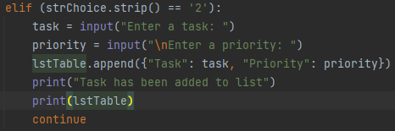

**Figure 1.**

**Removing data**

Data that is added to the list, (defined as lstTable), can be removed if the user selects option “3” from the menu. Option 3 defines “deltask” as an input variable that asks the user what they would like to delete. A for loop is then entered and the deltask is compared to the keys in the dictionary (previously defined as “task”). This code can be seen in figure 2 below. If this code matches code in the dictionary the *.remove* method is then applied to lstTable to remove the row from lstTable. If the input code is not found in lstTable, the code will print “this task does not exist”.

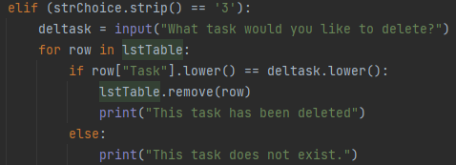

**Figure 2.** Code that allows the user to remove data. A code is entered and compared to dictionary keys.

**Saving data**

The final option for the user is to save the data. The program defines the saving destination to the variable *objFile* which is defined as “ToDoList.txt”. The code used to save the data is shown below in Figure 3.

Once the data is entered into a dictionary it is then saved to the list table using the code below.

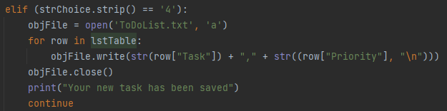

**Figure 3.** Code that saves the data to a text file.

**Conclusion**

In conclusion, this assignment demonstrated the challenges of working with someone else's code. I found it more challenging to work with someone else's code than with code that I had created myself. It demonstrated the importance of properly describing your code so that if someone else uses the code, they will know exactly what each block of code is designed to do.

**Screen Shots**

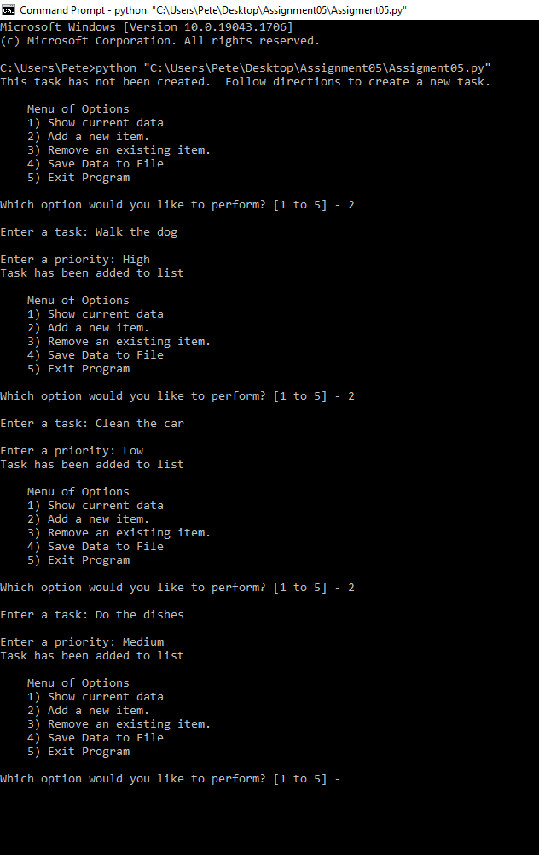

**Figure 4.** Working script in CMD

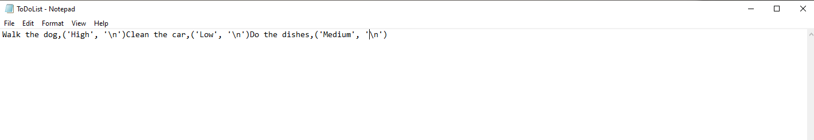

**Figure 5.** Output file ‘ToDoList.txt’ from running script in Figure 4.